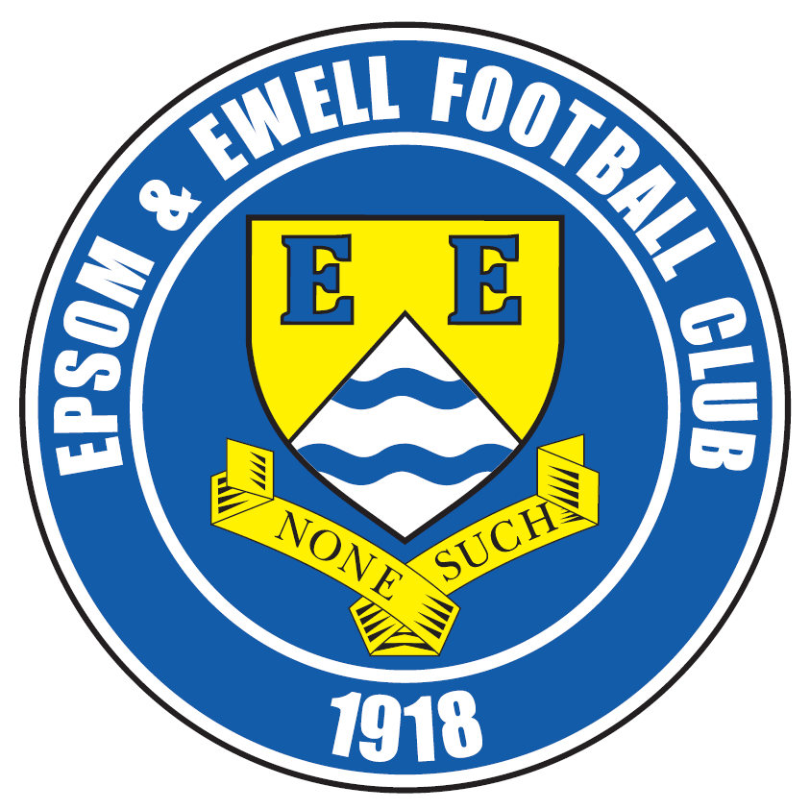 | Epsom & Ewell F.C.  8  v  Farnham Town  Saturday, 26th September 2015
Good afternoon! We welcome the players and officials of Farnham Town for today’s League match, together with our match officials and regular supporters.

Our opponents won here last season by four goals to two and it has to be said that it had been coming. In 2012/13 they had led by a goal at half time, only for us to turn it around to win 3-1 and in 2013/14 we were two goals down at half time before we scored three times in ten minutes to win 3-2. Last season we did manage to recover an early two goal deficit by half time but they were too strong on the day and pulled away again in the second period.

The position was reversed on the opening day of last season when we were the ones scoring twice in the second half with goals from Karl Douglin and Matt Farrell on his debut at the Memorial Ground.

Last Saturday we hosted AFC Hayes in a League match and despite taking a 19th minute lead through Matt Farrell we were unable to press our advantage home and had to settle for a 1-1 draw. We’ve played better but they were a decent team and will soon be picking up more points.

We travel to Cove next weekend and whilst on paper this looks a straightforward task, we still have to work hard and beat the players in front of us as they are well aware that they are in a relegation battle. It is a sad story for Cove when you see what many of their players are now achieving down the road at Hartley Wintney and I wonder whether the departures were as a result of Cove’s decision last season not to apply for promotion, as is required for all Step Five clubs that wish to be considered for a move to Step Four, just in case you weren’t aware.

There are costs associated with the application but they are not too bad and we can confirm that it remains our policy to apply for promotion every year and shall be doing so again this season.

Following that trip we are scheduled to see many of the old Oak Farm players when we visit Hartley Wintney in the League seven days later. However, if they defeat Merthyr in the F.A. Cup today, and we wish them well, then our match will be postponed with a midweek League Cup trip to Banstead being our next match on Tuesday 13th October.

Don’t forget the Super Six Predictor! The jackpot is now £211 so why not buy a ticket or two?

Enjoy the game!

Rich

Check us out on Facebook www.facebook.com/epsomandewellfc or on Twitter @EEFCOfficial

Cover photos by Gemma Jarman

- Matt Farrell puts us ahead on Saturday against AFC Hayes

- Dale Marvell scores against Farnham Town with a flying header in 2012/13


Cherry Red Records
Combined Counties League
Premier Division Table 2015/16
Inc Wednesday 23rd September | P | W | D | L | F | A | Pts | GD | H | A
Ashford Town (Mx) | 8 | 8 | 0 | 0 | 21 | 6 | 24 | +15 | 30/4 | 24/10
Camberley Town | 9 | 6 | 2 | 1 | 15 | 8 | 20 | +7 | 16/4 | 20/2
Hartley Wintney | 6 | 6 | 0 | 0 | 29 | 5 | 18 | +24 | 30/1 | 10/10
Horley Town | 7 | 6 | 0 | 1 | 19 | 5 | 18 | +14 | 27/2 | 28/12
Epsom & Ewell | 8 | 5 | 3 | 0 | 18 | 8 | 18 | +10 | X | X
Hanworth Villa | 7 | 5 | 1 | 1 | 15 | 5 | 16 | +10 | 21/11 | 23/4
Knaphill | 9 | 5 | 1 | 3 | 19 | 11 | 16 | +8 | 12/3 | 14/11
Chessington & Hook | 8 | 4 | 2 | 2 | 16 | 7 | 14 | +9 | 7/11 | 19/3
Colliers Wood United | 8 | 4 | 1 | 3 | 16 | 12 | 13 | +4 | 3-1 | 28/11
Guildford City | 9 | 4 | 1 | 4 | 14 | 19 | 13 | -5 | 5/12 | 2/4
Raynes Park Vale | 7 | 4 | 0 | 3 | 16 | 12 | 12 | +4 | 3-1 | 28/3
Windsor | 8 | 2 | 5 | 1 | 13 | 14 | 11 | -1 | 2-2 | 23/1
Westfield | 7 | 2 | 3 | 2 | 7 | 8 | 9 | -1 | 26/3 | 0-0
Farnham Town | 7 | 2 | 1 | 4 | 12 | 11 | 7 | +1 | 26/9 | 6/2
Sutton Common Rovers | 9 | 2 | 1 | 6 | 13 | 24 | 7 | -11 | 19/12 | 2-1
Bedfont Sports | 6 | 1 | 3 | 2 | 7 | 7 | 6 | +0 | 13/2 | 31/10
Chertsey Town | 8 | 1 | 2 | 5 | 6 | 13 | 5 | -7 | 17/10 | 5/3
Spelthorne Sports | 9 | 1 | 2 | 6 | 8 | 21 | 5 | -13 | 16/1 | 6-2
AFC Hayes | 7 | 1 | 1 | 5 | 4 | 10 | 4 | -6 | 1-1 | 9/1
Badshot Lea | 7 | 1 | 0 | 6 | 9 | 21 | 3 | -12 | 9/4 | 12/12
Cove | 8 | 1 | 0 | 7 | 5 | 29 | 3 | -24 | 8/12 | 3/10
Redhill | 8 | 0 | 1 | 7 | 7 | 23 | 1 | -16 | 2/1 | 1-0

Lucky Day? – 26th September
Played 16 - Won 7 Drawn 1 Lost 8 - F 33 A 29 - PPG 1.38 - Average
Our Club record against Farnham Town
Played 11 - Won 5 Drawn 2 Lost 4 - For 20 Against 21 - PPG 1.55 - Above Average
Largest wins and losses
1st December 2012 - Won 3-1 - League -- 20th March 2012 - Lost 1-4 - League
Last visit
Saturday 17th January 2015 - Lost 2-4 - Combined Counties League

Club Manager - Glyn Mandeville
Good afternoon everyone. We welcome Farnham Town and all their supporters for today's game.

I was gutted with last week’s result as I felt we should have done better against a poor side.

Never the less we are still on a good League run and the lads are in good spirits; we hope to make amends today by putting in a performance I know we have in our locker

Let's hope it's today, as Farnham will be a tough test as it always is.


Cheers for all your support and have a safe trip home. See you soon.

Manders

Club Captain - Sam Currie

Good afternoon and welcome to High Road for this afternoon’s game against Farnham. We welcome players, coaching staff and all supporters. As always we wish them a safe journey after what should be an entertaining game this afternoon.

Farnham as we all know is always a tough game, which will mean we will need to play to our full capabilities to ensure we keep our little run going that we are currently on.

Last Saturday saw us earn a point against AFC Hayes which at the time was certainly seen as a disappointing result considering we were at home and controlled large parts of the game. However in reality we know we were not at our fluent best and we did not manage to kill the game off when we were on top and it came back to haunt us with their equaliser.

When viewed in the grand scheme of things it was another point on the board and shows where we are this season and the quality we have that the boys are disappointed in this. We are making ourselves hard to beat in the league which is certainly a good foundation to have.

Today we will be looking to get back to winning ways and keep ourselves up the top end of the table as others around us are consistently picking up points too!

Thanks for your continued support.

Sam

Latest Results and Fixtures
Combined Counties League – Saturday 19th September
Ashford Town (Mx) | 4-1 | Hanworth Villa
Camberley Town | 2-0 | Bedfont Sports
Chertsey Town | 1-2 | Spelthorne Sports
Cove | 2-0 | Guildford City
Epsom & Ewell | 1-1 | AFC Hayes
Farnham Town | 1-4 | Horley Town
Hartley Wintney | 2-0 | Chessington & Hook United
Knaphill | 1-0 | Colliers Wood United
Raynes Park Vale | 4-1 | Badshot Lea
Redhill | 2-2 | Windsor
Sutton Common Rovers | 2-1 | Westfield
Combined Counties League Cup 1st Round – Tuesday 22nd September
Farnham Town | 3-1 | Ash United
Combined Counties League – Tuesday 22nd September
AFC Hayes | 0-1 | Camberley Town
Badshot Lea | 0-7 | Chessington & Hook United
Horley Town | 3-0 | Sutton Common Rovers
Spelthorne Sports | 1-1 | Bedfont Sports
Windsor | p-p | Cove
Combined Counties League – Wednesday 23rd September
Guildford City | 3-2 | Knaphill
Combined Counties League – Friday 25th September
Hanworth Villa | V | Knaphill
Emirates F.A. Cup – Second Qualifying Round – Saturday 26th September
Merthyr Town | V | Hartley Wintney
Combined Counties League – Saturday 26th September
AFC Hayes | V | Horley Town
Badshot Lea | V | Chertsey Town
Chessington & Hook United | V | Cove
Epsom & Ewell | V | Farnham Town
Guildford City | V | Colliers Wood United
Redhill | V | Raynes Park Vale
Spelthorne Sports | V | Sutton Common Rovers
Westfield | V | Ashford Town (Mx)
Windsor | V | Camberley Town
Combined Counties League – Tuesday 29th September
Camberley Town | V | Ashford Town (Mx)
Latest Results and Fixtures
Combined Counties League – Tuesday 29th September
Colliers Wood United | V | Spelthorne Sports
Cove | V | Epsom & Ewell
Guildford City | V | Raynes Park Vale
Combined Counties League Cup 1st Round – Friday 2nd October
Dorking Wanderers Reserves | V | South Park Reserves
F.A. Vase Second Qualifying Round – Saturday 3rd October
Beckenham Town | V | Redhill
Chertsey Town | V | Tadley Calleva
Cobham | V | Sutton Common Rovers
Cogenhoe United | V | AFC Hayes
Fairford Town | V | Badshot Lea
Hanworth Villa | V | Oxhey Jets
Hartley Wintney | V | Milton United
Knaphill | V | Lydney Town
Malmesbury Victoria | V | Farnham Town
Westfield | V | Carterton
Windsor | V | Royal Wootton Bassett Town
Combined Counties League Cup 2nd Round – Saturday 3rd October
Worcester Park | V | Chessington & Hook United
Combined Counties League – Saturday 3rd October
Camberley Town | V | Ashford Town (Mx)
Colliers Wood United | V | Spelthorne Sports
Cove | V | Epsom & Ewell
Guildford City | V | Raynes Park Vale
Combined Counties League – Tuesday 6th October
Bedfont Sports | V | AFC Hayes
Farnham Town | V | Westfield
Horley Town | V | Windsor
Combined Counties League – Wednesday 7th October
Colliers Wood United | V | Ashford Town (Mx)
Combined Counties League Cup 2nd Round – Saturday 10th October
Sheerwater | V | Frimley Green
Combined Counties League – Saturday 10th October
AFC Hayes | V | Guildford City
Ashford Town (Mx) | V | Raynes Park Vale
Badshot Lea | V | Horley Town
Latest Results and Fixtures
Combined Counties League – Saturday 10th October
Chertsey Town | V | Westfield
Colliers Wood United | V | Windsor
Farnham Town | V | Hanworth Villa
Hartley Wintney | prov | Epsom & Ewell
Dependent on Hartley’s F.A. Cup tie at Merthyr Town this afternoon
Knaphill | V | Camberley Town
Redhill | V | Bedfont Sports
Spelthorne Sports | V | Cove
Sutton Common Rovers | V | Chessington & Hook United
Combined Counties League Cup 2nd Round – Tuesday 13th October
AFC Hayes | V | Raynes Park Vale
Ashford Town (Mx) | V | Epsom Athletic
Badshot Lea | V | Spelthorne Sports
Banstead Athletic | V | Epsom & Ewell
Bedfont & Feltham | V | Colliers Wood United
Camberley Town | V | Eversley & California
Cove | V | Cobham
Dorking | V | Knaphill
Farnham Town | V | Abbey Rangers
Hanworth Villa | V | Chertsey Town
Hartley Wintney | V | Horley Town
Redhill | V | Sutton Common Rovers
Westfield | V | CB Hounslow United
Combined Counties League – Saturday 17th October
Badshot Lea | V | AFC Hayes
Bedfont Sports | V | Ashford Town (Mx)
Chessington & Hook United | V | Knaphill
Cove | V | Redhill
Epsom & Ewell | v | Chertsey Town
Guildford City | V | Spelthorne Sports
Hanworth Villa | V | Camberley Town
Horley Town | V | Colliers Wood United
Raynes Park Vale | V | Hartley Wintney
Sutton Common Rovers | V | Farnham Town
Windsor | V | Westfield
Combined Counties League – Tuesday 20th October
Chessington & Hook United | V | Colliers Wood United
Raynes Park Vale | V | Farnham Town

First Eleven Appearances - (max 10 – including AFC Hayes – 19/09/15)
Name | Debut | 2014/15 |  |  |  | Career Totals
Name | Debut | App | Sub | Total | Goals | App | Sub | Total | Goals
AJAYI Tayo | 22/08/2015 | 0 | 2 | 2 | 0 | 0 | 2 | 2 | 0
COOPER-SMITH Daryl | 03/01/2015 | 7 | 3 | 10 | 4 | 16 | 6 | 22 | 10
CURRIE Sam | 04/08/2012 | 9 | 1 | 10 | 0 | 117 | 10 | 127 | 2
DAVISON Conor | 22/08/2015 | 0 | 2 | 2 | 0 | 0 | 2 | 2 | 0
DEAN Dan | 02/08/2014 | 10 | 0 | 10 | 0 | 46 | 1 | 47 | 0
DEWAR Ali | 29/10/2011 | 0 | 0 | 0 | 0 | 55 | 35 | 90 | 10
EACOTT Michael | 02/08/2014 | 9 | 0 | 9 | 0 | 55 | 0 | 55 | 0
FARRELL Matt | 02/08/2014 | 9 | 0 | 9 | 2 | 50 | 3 | 53 | 9
FERDINANDO Matt | 20/09/2014 | 5 | 0 | 5 | 0 | 32 | 4 | 36 | 6
GRIFFIN Reisse | 08/08/2015 | 5 | 0 | 5 | 0 | 5 | 0 | 5 | 0
HASTINGS Craig | 08/08/2015 | 5 | 3 | 8 | 0 | 5 | 3 | 8 | 0
HENDRY Rob | 08/08/2015 | 9 | 1 | 10 | 3 | 9 | 1 | 10 | 3
HOUGH Kyle | 14/08/2007 | 9 | 0 | 9 | 7 | 305 | 15 | 320 | 178
KURDZIEL Jakub | 29/08/2015 | 1 | 0 | 1 | 0 | 1 | 0 | 1 | 0
MARVELL Dale | 15/01/2000 | 7 | 1 | 8 | 0 | 268 | 46 | 314 | 85
MCGREGOR Alex | 08/08/2009 | 3 | 2 | 5 | 1 | 175 | 58 | 233 | 28
MCKAY Alex | 20/12/2008 | 3 | 1 | 4 | 0 | 88 | 27 | 115 | 8
NORTH Rhys | 16/08/2015 | 1 | 3 | 4 | 0 | 1 | 3 | 4 | 0
OLIVER Beckett | 29/08/2015 | 2 | 2 | 4 | 0 | 2 | 2 | 4 | 0
PANAYIOTOU Savvas | 03/01/2015 | 2 | 0 | 2 | 0 | 18 | 3 | 21 | 3
SMITH Matt | 08/08/2009 | 0 | 0 | 0 | 0 | 91 | 43 | 134 | 10
TANTON Matt | 02/08/2014 | 8 | 0 | 8 | 0 | 26 | 4 | 30 | 1
TAYLOR James | 26/08/2013 | 6 | 1 | 7 | 0 | 62 | 9 | 71 | 3
Own Goal |  |  |  |  |  |  |  |  | 1

From behind the goal
Spelthorne Sports 2-6 Epsom & Ewell
Combined Counties League Premier Division - Sunday 6th September 2015

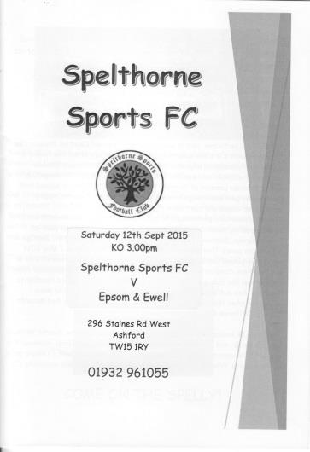
Salts smash Spelthorne for six!

As any regular football supporter will know, the club you follow will have highs and lows, but the highs make it all worthwhile. One of those occurred at Spelthorne on Saturday, when not only did we produce a fantastic hard working performance but some stunning finishes ensured this match will also be remembered later this year when the goals of the season are considered.

In terms of personnel, the only changes from Tuesday's win over Colliers Wood United were on the flanks where the injured and suspended Matt Ferdinando and the absent Beckett Oliver were replaced by Rob Hendry and Daryl Cooper-Smith. Alex McGregor moved out to the right with Cooper-Smith supporting Kyle Hough up front and we hit the ground running with good pressure from the start.

McGregor whipped a free kick wide of the near post as early as the third minute before we opened up our account five minutes later. The home defender wouldn't have been too happy with his keeper as he received a pass when he wasn't expecting it and lost the ball to Hough almost immediately who rolled the ball towards the incoming Cooper-Smith who casually lashed the ball right into the top corner from 12 yards out.

Cooper-Smith forced a good save from the home keeper with a shot from outside the area soon after this before Hough was clattered by their Captain; a challenge that really warranted a yellow card, but it wasn't even a foul as our man had just been flagged offside before being taken out. Fortunately it wouldn't matter as today would be a good day all over the park with questions being answered about how we would cope if we were ever to miss our talisman for a game or two.

However, it wouldn't be an Epsom match without a bit of adversity and the home side duly equalised in the 16th minute when the left winger got around Sam Currie and laid the ball back for a shot at goal. The shot was well blocked by our defenders but the loose ball went across goal to Liam Vickery and he drove the ball beyond Michael Eacott and into the corner from just inside the penalty area.

This was unfortunate as it was the first time we had really been threatened, but our response was immediate as Cooper-Smith was put through on the left and although his ball across the six yard box was just beyond the incoming Matt Farrell, McGregor was at the far post and smashed the ball into the roof of the net from quite a narrow angle

about thirty seconds after conceding.

Cooper-Smith made an identical run a few minutes later and rounded the keeper who may have made a slight contact with him. If he had gone down at that point we may even have had a penalty, but he didn't go down immediately and so when he fell shortly after this, it looked a bit obvious and ultimately he was fortunate not to receive a card for diving.

Not that it made any difference to the pattern of the game as we streamed forward and our third goal was started off by a smart reverse pass from Hough to Farrell on the right. His cross was met at the back post by Cooper-Smith who set up Hendry to give the keeper no chance with a great low drive from ten yards in the 31st minute. It was a really good move as we cut the hosts to pieces.

Eacott watched a long range effort just clear his bar and had to be alert to tip another dipping effort away, but we could reflect on a job well done to this point as the players walked off at the half.

As the second half commenced we were aware that the home side had added a twelfth player on the park in the shape of an escaped beagle, but he only stuck around long enough to pose for the cameras before trotting off! In truth this was the only thing the home side could laugh about as a team with six straight defeats were clearly facing a seventh one and we were in no mood to let up either, extending our lead in the 55th minute when McGregor held the ball up on the right before feeding the overlapping Currie and his superb deep cross was met at the far post with a great volley from Hendry that flew into the net from an acute angle.

Five minutes later it was 5-1 as Hendry got free on the left and his cross was met at the back post with a textbook centre forward's downward header from Cooper-Smith. There wasn't much in the way of defenders around him but it was still a good finish. Hendry created another chance a few minutes later when he beat two men and pulled the ball back from the touch line but there was no one there to apply the finish.

A good header from the home side clipped the top of our crossbar while substitute Rhys North nearly scored with a super effort from at least thirty yards out on the right but could only watch as the ball cannoned off the bar and away. As the game reached its final moments the home side scored a second as Myles Henry rode a challenge and then lobbed Eacott from twenty yards, but we again responded immediately with a ball through to Hough who wrapped up the scoring by rounding the keeper and walking the ball into an empty net.

The win takes us up to second place in the fledgling table while Spelthorne face a long season. Having said that, there was a lot of quality on show and we would have done this to some significantly better teams this afternoon. A top performance all round.

Team: Michael Eacott, Sam Currie ©, Matt Tanton, Dan Dean, Craig Hastings, Alex McKay, Rob Hendry, Matt Farrell, Kyle Hough, Daryl Cooper-Smith, Alex McGregor

Subs: James Taylor for Currie (70), Rhys North for McGregor (75), Dale Marvell for Hastings (81)

Club Records - 26th September
Date | Day | Competition |  | Opponents |  | Scorers
26/09/25 | Sat | Friendly | H | Botwell Mission | 1-5 | o.g.
26/09/28 | Wed | East Surrey Hospital  Cup Final | H | Lloyds Bank | 2-4 | W.Challis, H.Westlake (pen)
26/09/31 | Sat | London League | H | Carshalton Athletic | 3-1 | B.Williams (3)
26/09/36 | Sat | Amateur Cup  Preliminary Round | A | Banstead Mental Hospital | 6-0 | T.Rochester (2 pens), T.Dunne (2), J.Morgan, B.Randall
26/09/53 | Sat | F.A. Cup 1q | A | Met Police | 2-1 | R.Holloway, S.Scott
26/09/59 | Sat | Amateur Cup  Preliminary Round | A | Worcester Park | 3-0 | J.Bangs (2), J.Sorensen
26/09/64 | Sat | Athenian League 1 | A | Harrow Town | 2-3 | B.Mackay, T.Higgins
26/09/70 | Sat | Amateur Cup 1q | A | Lion Sports | 0-4
26/09/78 | Tue | Isthmian League 1 | H | Hampton | 1-1 | R.Breen
26/09/81 | Sat | Isthmian League 1 | H | Oxford City | 1-0 | T.Coombe
26/09/87 | Sat | F.A. Cup 2q | A | Met Police | 0-3
26/09/89 | Tue | Isthmian League 2s | H | Abingdon Town | 3-0 | B.Perkins (2), P.Andrews
26/09/92 | Sat | Isthmian League 3 | H | Petersfield United | 2-4 | M.Alcindor (2)
26/09/95 | Tue | Isthmian League 3 | H | Cove | 6-0 | A.Boxall (3), S.Miller, P.Meredith, T.Smith
26/09/98 | Sat | Isthmian League 3 | A | Camberley Town | 1-2 | T.Boorman
26/09/09 | Sat | Combined Counties League  Premier Division | A | Colliers Wood United | 0-1
Historical Decades
90 years ago – Epsom Town F.C.
26/09/25 | Sat | Friendly | H | Botwell Mission | 1-5 | o.g.
80 years ago – Epsom F.C.
28/09/35 | Sat | London League | H | Eton Manor | 6-3 | H.Pullen (3), J.Jones, G.Collins, L.Graves
70 years ago – Epsom F.C.
29/09/45 | Sat | Amateur Cup Prelim Round | H | Banstead Hospital | 0-1
60 years ago – Epsom F.C.
24/09/55 | Sat | F.A. Cup 1q | H | Dover | 3-2 | J.Sorensen (pen), D.Hermitage, G.Cairns
50 years ago – Epsom & Ewell F.C.
25/09/65 | Sat | Amateur Cup  Preliminary Round | H | Cobham | 5-0 | T.Thomas (2), B.Harding, M.Griffiths, T.Wiltshire
40 years ago – Epsom & Ewell F.C.
22/09/75 | Mon | F.A. Cup 1q 2nd replay | N | Southall & Ealing Borough | 1-5 | P.Walker
30 years ago – Epsom & Ewell F.C.
28/09/85 | Sat | Isthmian League Premier | A | Hendon | 0-3
20 years ago – Epsom & Ewell F.C.
26/09/95 | Tue | Isthmian League 3 | H | Cove | 6-0 | A.Boxall (3), S.Miller, P.Meredith, T.Smith
10 years ago – Epsom & Ewell F.C.
28/09/05 | Wed | Associate Members Trophy Group Match | H | Camberley Town | 2-1 | D.Marvell, L.Gay

History Corner – 26th September
90 years ago today we suffered our first ever defeat at West Street!!

Botwell Mission was a Spartan League team when they visited us for a challenge friendly this very day 90 years ago. They got their name from the fact that they changed into their kit at the small mission church near to their ground in Church Road.

The Spartan League was a level higher than us back in those days and so maybe it was no surprise that we were defeated 5-1; our only score coming from an own goal. The club changed its name in 1929 and became much more well known as Hayes F.C.

85 years ago today we had a 3-1 league victory at home to Carshalton Athletic. However, this match would be remembered for the debut of Billy Williams, a former Schoolboy International and former professional at West Ham United who scored all three goals and would go on to get 41 in just 26 appearances this season. Who knows how many more he could have scored this season, but because he was a “permit player” he was not allowed to play in Amateur competitions like the Amateur Cup.

The real question here is why would a player who lived in Ilford and had previously been paid for his work, choose to move to Epsom? The answer is because he was a business partner of our Captain at the time George Mackesy, and in 1936 when Williams was by then at Dagenham, Mackesy ended ten years of service for us by moving to play for them instead.

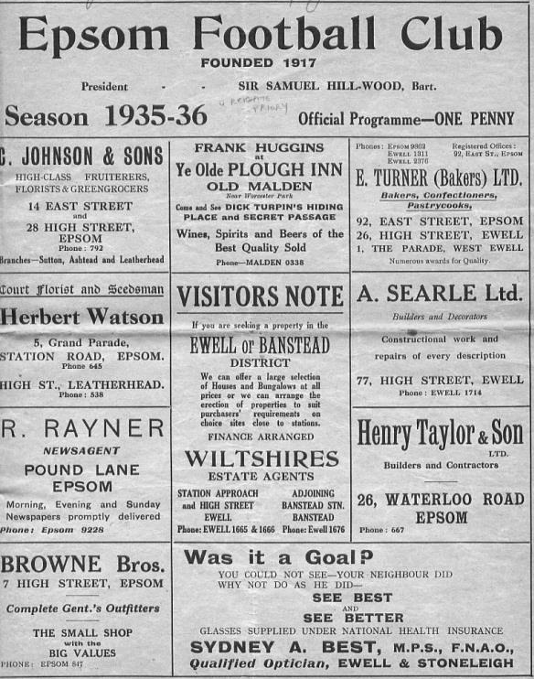
80 years ago this week Jackie Pullen scored a hat trick in a 6-3 win over Eton Manor in a London League match. Pullen had already become a legend at his former club Mitcham Wanderers but following a couple of years at the newly merged Tooting & Mitcham United he joined us in December of 1934 and became a legend here too, becoming one of only eight players in history to score over a hundred goals for our club. (see programme right)

40 years ago this week we were defeated in a second replay of an F.A. Cup tie by Isthmian top flight club Southall and Ealing Borough; a club that were three divisions above us. Although the defeat at Dulwich Hamlet’s Champion Hill ground was a heavy one, the loss is most notable for the final goal scored for the club by Phil Walker in what would prove to be the final game for both he and Trevor Lee before signing for Millwall in early October.

20 years ago today Cove were put to the sword by six clear goals at Merland Rise. In 1995/96 we scored a lot of goals; as many in fact as the top two in the table that year. Four players reached double figures this season while Andy Boxall led the way with 29 in just 40 matches and he got three this evening too as we were five-nil up by half time. Stuart Miller, Paul Meredith, and Tim Smith got the other three goals but this match would be put in the shade a few months later when we would defeat Tring Town 11-1!

Centre page for results

Centre page for results



From behind the goal
Epsom & Ewell 1-1 AFC Hayes
Combined Counties League Premier Division - Saturday 19th September 2015

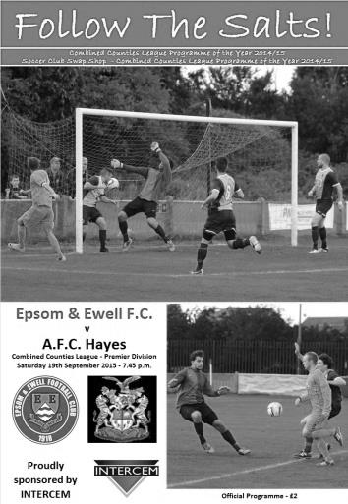
Below par performance only good enough for a draw

The recent memories of great wins over Colliers Wood United and Spelthorne Sports were tempered somewhat by a performance that was of a far lesser quality and visiting AFC Hayes took advantage of this by restricting us to just a point in a 1-1 draw. It was a fairly even game with our boys taking the lead nineteen minutes from the start and the visitors equalising nineteen minutes from the end!

You could argue some mitigating factors; the absence of Kyle Hough due to a family engagement, the dry pitch preventing flowing football, or even an extremely erratic match official who saw fouls that weren't there but would miss others that were blatantly obvious, although ultimately we have no one else to blame for our failure to record our fourth straight League win and dropped down the league table as a result.

We made some changes to the line-up following our win at Spelthorne seven days previously. Dale Marvell came back into the starting line up to replace the absent Hough and played in midfield with Rob Hendry given the task of trying to emulate our leading scorer. At the back, James Taylor took Sam Currie's place at right back, although our club Captain would see action later.

We started the game brightly, as a team in second place should. Daryl Cooper-Smith was sent down the left by Marvell and he cut in and shot at goal, only to see the visiting keeper Bobby Khiara tip the ball around the post as early as the fifth minute. The visiting keeper was in action seven minutes later when an Alex McKay long throw nearly went over his head but he just got a fingertip to the ball. In the nineteenth minute he was less fortunate, making a meal of a low Hendry cross from the left and spilling it in front of Matt Farrell who swept the ball into the vacant net.

Marvell was next to strike at goal but his ball struck the wall and although it deflected towards goal, it had no power left and was gathered by the grateful Khiara.

All of this was in the first twenty five minutes but we were unable to progress that position to any further advantage and the game became more even from that stage, with less real opportunities for either side. A defensive clearance from Matt Tanton was

charged down and the visitors had an opportunity that they switched to the left but Michael Eacott was down to block the low shot for a corner and as we reached the half Farrell had a chance but was well wide on the left and he was unable to curl the ball into the net, his shot just dropping beyond the far post.

Right on half time the visitors came close flicking on a header that Tanton was able to head clear at the far post but our players were well aware as they walked off at half time that this game was far from over. Any concerns weren't helped by a series of erratic decisions by the referee and he confused just about everyone in the ground as the second half commenced when a visiting defender prevented us from taking a quick free kick by belting the ball forty yards out of the ground but no action was taken.

However, just four minutes later Daryl Cooper-Smith knocked the ball away only to then receive a yellow card for his trouble; a quite bizarre decision to penalise one but not the other "offence", and overall the official was fortunate that the players of both teams were keen to play football as this game could easily have seen players trying to take the law into their own hands. Hendry then found himself in the book for a challenge that looked completely fair!

Hendry had a chance at the far post but he couldn't keep the shot down, while an Alex McGregor cross just eluded Marvell at the far post. Moments later Dale was presented with a golden chance after a great pass from Hendry split the defence but his shot was off target from just twelve yards and even though the keeper got a touch on the ball, it wasn't significant except to earn us a corner which we are unable to take advantage of.

And after 71 minutes we were made to pay with a quite strange goal. Eacott was the first player to react to a long pass which begs questions about where our defenders were, but he was dispossessed on the edge of his area by Josh Quadry who shot at goal from the edge of the box. It wasn't the strongest of strikes but just crept in the corner despite a defender on the line who was unable to reach it.

From this point the game could have gone either way. We continued to look slightly more dangerous but service from the flanks was poor and you can't just replace a player of Hough's ability. We made further substitutions and finished the stronger of the teams but also had to be alert with Eacott making another two good low saves in the final five minutes.

Ultimately we didn't do enough to deserve the three points against a team that were beaten in midweek by a Chertsey side that then lost to Spelthorne this weekend. Whilst we could throw a few excuses in, they won't change the result and we have to realise that we will have to work harder if we are not to drop points in the future, starting next week when Farnham Town visit us.

Team: Michael Eacott, James Taylor, Matt Tanton, Dan Dean (c), Craig Hastings,
Alex McKay, Dale Marvell, Matt Farrell, Rob Hendry, Daryl Cooper-Smith,
Alex McGregor

Subs: Beckett Oliver for McGregor (61), Tayo Ajayi for Cooper-Smith (81), Sam Currie for McKay (81)

Farnham Town – History
Established in 1906 through the merging of Farnham Bungs (the Farnham Brewery) and the Farnham Star. The club was one of the founder members of the London Spartan League in 1975. They reached the Fourth Round of the FA Vase in the 1976-77 season.

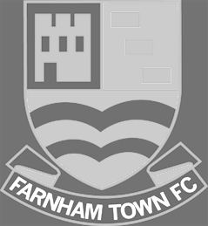
At the end of the 1979/80 season Farnham Town left the London Spartan League and applied to the Combined Counties League, their application was accepted and they finished 4th in their first season. The 1986/87 season saw Farnham take second place to Ash United in the league campaign. The glory days finally arrived in the 1990/91 season when the club won the league title. In the 1991/92 season, the Town got a clean sweep of the major trophies by winning the Combined Counties Premier League, the Dan Air Elite Cup and the Dan Air Challenge Cup. Having won the league, the club applied and were accepted to the Diadora League, however funds for necessary ground improvements could not be generated which resulted in the club not having a league to play in for the 1992/93 season.

In 1993/94 Farnham Town were accepted back into the Combined Counties League where they continue to ply their trade. From 1995-1998 Farnham finished in the top six of the Premier Division for three consecutive seasons, in 1998-99 they finished in 13th position, then 10th in 1999-2000 before suffering relegation from the Premier Division in 2000-2001 season. They bounced straight back the following season but then endured four tough seasons back in the Premier Division, with bottom four finishes every season culminating in relegation back down to Division One in 2005-2006. Again, the club bounced straight back and in 2006-2007 they won the Division One title under the guidance of Barry Bridger, but were denied promotion due to the Memorial Ground not meeting the desired grading by the league. The club then spent another four seasons in Combined Counties Division One.

Farnham gained promotion from Combined Counties Division One in the 2010-2011season after finishing second behind Worcester Park. In Paul Tanner’s first season at the helm he gained automatic promotion back to the Premier Division at the first attempt, which after only retaining four members of the side from the previous year’s squad - who finished midtable, was quite an achievement. Paul Tanner’s side also won the Combined Counties Fair Play Award for 2010-2011 after going the whole season without having a man sent off, a record to be proud of. In a very successful year for the club on the whole, Dean Nelson’s reserve side finished second behind Mole Valley in the Combined Counties Reserve Division, improving on fourth position the previous season. Farnham Ladies also finished second in their respective league to cap quite a remarkable season in Geoff Chapple’s final season as Chairman. In 2011, Ray Bridger took over as chairman from Geoff Chapple.

Current first team manager and now in his 7th season at the club is Paul Tanner, alongside head coach Sean Birchnall.

Match and Ball Sponsorships – 2015/16
Opponent | Date | Match and Match Ball Sponsor
Hoddesdon Town | 18/07/15 | Geoff Dyke
Windsor | 08/08/15 | Club President Stella Lamont
Erith & Belvedere | 16/08/15 | Mike Lovett
Raynes Park Vale | 31/08/15 | EEFC Management Committee
Colliers Wood United | 08/09/15 | Bookham Building Shop – www.buildingshop.co.uk
AFC Hayes | 19/09/15 | John Bonner
Farnham Town | 26/09/15 | Ezara and Inaya Beddoe – our youngest supporters!
Chertsey Town | 17/10/15 | Club Media Officer – Richard Lambert
Dorking Wanderers (SSC) | 20/10/15
Chessington & Hook United | 07/11/15
Hanworth Villa | 21/11/15
Guildford City | 05/12/15
Cove | 08/12/15
Sutton Common Rovers | 19/12/15
Redhill | 02/01/16
Spelthorne Sports | 16/01/16
Hartley Wintney | 30/01/16
Bedfont Sports | 13/02/16
Horley Town | 27/02/16
Knaphill | 12/03/16
Westfield | 26/03/16
Badshot Lea | 09/04/16
Camberley Town | 16/04/16
Ashford Town (Mx) | 30/04/16
For League, League Cup and Surrey Senior Cup Matches:
Match sponsorship - £40.00 Match ball sponsorship - £25.00. Combined £55.00.
For F.A. Cup and F.A. Vase matches:
Match sponsorship - £50.00 Match ball sponsorship - £30.00. Combined £65.00.

Sponsorship includes: (x2 for match, x3 for match and ball)

Admission, programmes, hospitality and advertising and mascot for the day (if required).
If you are interested, just speak to a Committee Member, or drop me an email at: richard.c.lambert@gmail.com


We also thank our Kit Sponsors INTERCEM

Player Sponsorship
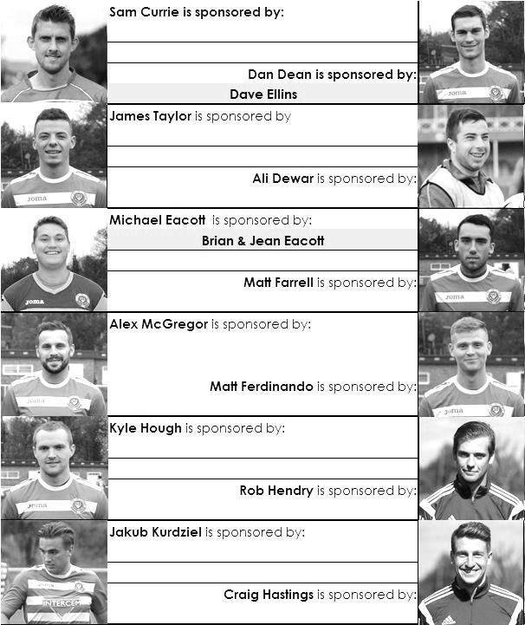

Here is the updated list for the 2015/16 season showing all of our players and Management that are currently available for sponsorship this season. Pictures for our new players are now here!

Sponsorship costs just £40 and it is easy to do. Just select a player who has not been previously sponsored and let a Committee Member know that you would like to sponsor them. Beware though. Until we have received the money it is possible for someone to jump in front of you, so don’t delay, sponsor today!

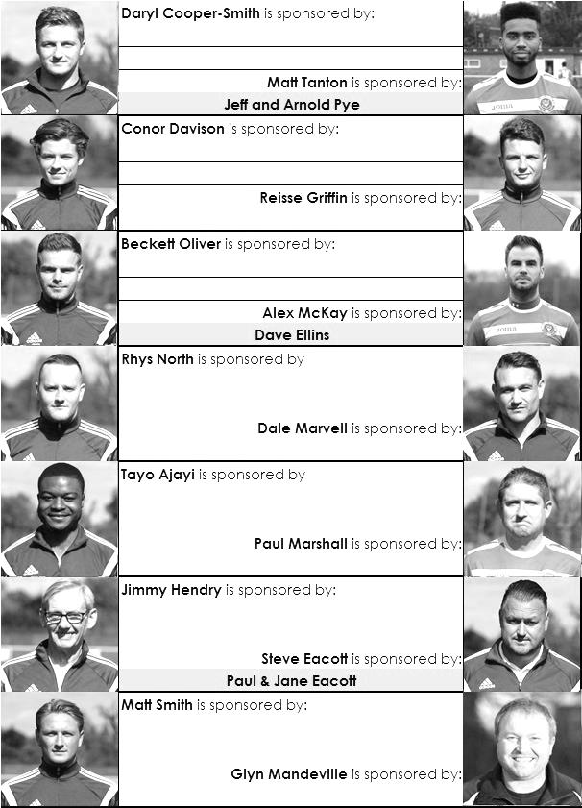

Early Results Grid
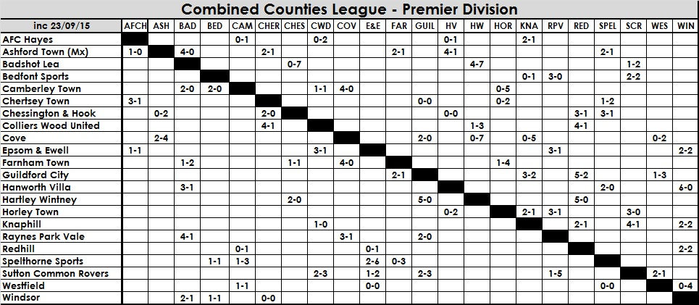

Player Profile – Number 5 – Ali Dewar
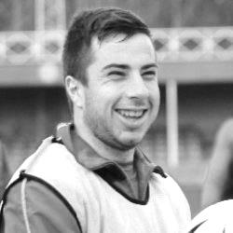
Our latest player profile is from Ali Dewar. Ali has been really unlucky to be affected by a number of injuries in his time with us but is still only 22 so has time to make many more appearances as he closes in on the hundred mark.

Age: 22

Position: Winger / Striker

Club supported: Chelsea

Favourite Food: Nandos

Favourite Film: Frozen

Messi or Ronaldo: Messi

Favourite Drink: Kopparberg

Favourite Ground played at: Kingsmeadow, A.F.C. Wimbledon

Best moment for Epsom: Not being injured!!

Describe the Gaffa in three words: Large – Ginger – Banter

Ali’s Playing Stats: Debut 29/10/11 - Total Appearances: 90 - Total Goals: 10
Win Ratio (the amount of games he has played in that we have won) 50.00%

Salts Super Six Predictor
The Salts Super Six Predictor Competition is live again and the tickets are on sale at today’s game to the left of the gate. Six Premier League fixtures are on the list this week, all of which take place this afternoon.

The competition is easy to play! To win, you simply need to predict the results of six matches correctly from the three options, fill in the form and make sure it is back with our sellers before the deadline on the ticket.

If you are a club regular, you just need to place your name on the sheet, although if you aren’t, then we’ll need a contact number from you too. We will announce any winners on the website within three working days, so don’t worry we won’t miss you!

We nearly had a winner last week but the jackpot keeps rising and is already up to £211 How much higher can it go?

Please note that if there is more than one winner, the prize pot would be shared between the winners. All you need to do now is have a go, as many times as you like!

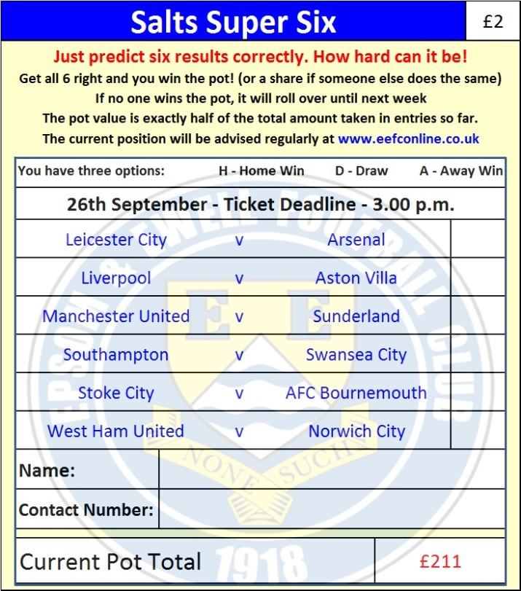

Good luck!

Combined Counties League – Premier Division
Saturday, 26th September 2015 - Kick-off 3.00 p.m.
Epsom and Ewell  (Royal Blue & White hoops) | V |  | Farnham Town  (Claret and Blue)
Squad | NUMBERS
Michael Eacott |  |  | Matt Petts
© Sam Currie |  |  | Max Meaton
Matt Tanton |  |  | Matt Graham
Dale Marvell |  |  | Lee Marker
James Taylor |  |  | Darren Wilson
Dan Dean |  |  | Sean Evans
Matt Farrell |  |  | Ben Williams
Alex McKay |  |  | James Thomas
Kyle Hough |  |  | Tom Smith
Daryl Cooper-Smith |  |  | Steve Ramsden
Rob Hendry |  |  | Jack Dillion
Reisse Griffin |  |  | Elliot Cardona
Conor Davison |  |  | Josh Dixon
Jakub Kurdziel |  |  | Ross Cheek
Rhys North |  |  | Tom O’Reilly
Tayo Ajayi |  |  | Ollie Macallum
Matt Ferdinando |  |  | John Lancashire
Craig Hastings |  |  | Matt Glass
Beckett Oliver |  |  | Mark Corbett
Alex McGregor |  |  | Luke Whiddett
David Neill
Glyn Mandeville | MANAGER |  | Paul Tanner
Matt Smith | ASSISTANT |  | Sean Birchnall
Steve Eacott / Alex McKay / Jimmy Hendry | COACHES / PHYSIO |  | Alan Read / Andy Sharat /  Dean Nelson
REFEREE: A.Connor (Farnham)
ASSISTANTS: J.Lidbetter (Surbiton), R. van Niekerk (Sutton)
Today’s Match and Match Ball are sponsored by
Ezara (3) & Inaya Beddoe (5 mths), our youngest Club Members!

OUR NEXT VISITORS TO HIGH ROAD
Chertsey Town
Saturday 17th October 2015 - Kick-off 3.00 p.m.
Combined Counties League – Premier Division

